IPM Water Quality Project / NRCS IPPC

Phenology Models for Pest Management

What are Phenology Models & Why Use Them?

Insect pest and disease phenology models are tools that can help you decide if and when to apply pesticides. They can help you:

- Time sprays for maximum efficacy
- Improve efficiency of sampling to determine pest levels and stages in the field
- Eliminate unnecessary sprays
- Reduce overall pesticide loading of the environment
- Reduce potential for resistance development

By using these models, you may realize savings that result from lower material and application costs. You may also be able to sample your pests more efficiently (and avoid wasted effort) by knowing when to look. Also, you may improve the timing of pest controls to improve crop yield and quality. It should be emphasized that models are tools that are used in the overall decision-making process, but are not intended to be relied on exclusively. You need to use common sense as well.

Examples of commonly used insect and disease models include:

- Codling moth development model: a degree-day model to help time spray applications. There are similar development models for obliquebanded leafroller, San Jose scale and dozens of other species.
- First emergence models (ex. Apple Maggot, Cherry Fruit Fly, and Filbert worm): predict when a pest has emerged to initiate spray programs.
- Cougarblight fire blight risk calculator: use degree-hours to estimate the potential for the build up of fire blight bacteria in pear blossoms, and help in decisions on if and when to spray.
- Powdery mildew risk model: use temperatures and leaf wetness relevant to ascopsopores and conidia of powdery mildew to adjust intervals between treatments.

Models are a way of simulating the developmental events in the life cycle of an organism (pest or disease). Some are relatively simple; others may involve the use of complex mathematical equations. Fortunately, they are often integrated into a look up table or a computer program that is convenient to use. Because the rate of development of pests and diseases is primarily driven by temperature, it is necessary to have weather data available for calculating the models. You may collect your own weather data and calculate the models using look-up tables. Using the web-based tools that are demonstrated below provides the following advantages:

- access to weather data that is collected automatically
- simplified data management and model calculations
- access to summaries that have been completed for you
- access to e-mail alerts on critical events in pest or disease development

Accessing Phenology Models in the Pacific Northwest
Many locations in the Northwest have access to near-real time data from a network of weather stations with locations in most of the different districts of the valley. A variety of weather networks are available, including National Weather Service (NWS), Dept. Interiors/Bureau of Reclamations' AgriMet network, and certain publicly shared grower-supported networks such as those in Hood River, Medford, and The Dalles in Oregon.

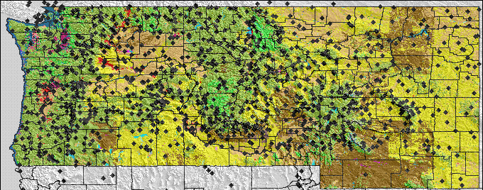
Fig. 1. Online weather stations available for phenology models from http://pnwpest.org/wea. Over 1100 stations representing networks including NWS METAR (airport) and COOP (mostly urban), Bur. Reclamation AGRIMET and HYDROMET, several grower operated or supported networks, US Forest Service and Bureau of Land Management RAWS, and NRCS Snotel.

To augment the networks in or near agricultural areas, the inclusion of non-agricultural networks allows the web-based tools the ability to better estimate missing data, and to interpolate pest development in locations not close to any other stations.

In most cases, only the daily maximum, minimum temperature, plus precipitation are extracted and stored from these networks to use for pest models. For most of the grower-supported networks, data are delivered real-time every 15 minutes.
Currently, there are three web-based resources to be aware of:
- Online IPM Weather Data
- Online Phenology and Degree-day Models
- Online phenology maps (daily and custom)
The key features and access to each are described below.

Online IPM Weather Data (example given for Hood River Valley): http://pnwpest.org/hr/
This website provides access to the current 15 minute weather observations for each of the stations in the MCAREC grower-supported weather network. It also has several other features. The main features are near-real-time updates on the status of pear scab infection periods.

The pear scab infection period model is a degree-hour adaptation of the Spotts Table that uses temperature and leaf wetness data to calculate when environmental conditions required for a pear infection period are occurring. To check for the current status of infection periods, click on "today" for the appropriate weather station. If you want to see if there has been an infection period during the preceding 5 days, choose from one of the "today-x'' selections.

You will find background information on the model by clicking on "pear scab model test". You should read the disclaimer by clicking on "pear scab model test" and know that this model is still being tested The new model is similar to the Cougarblight model in that it calculates degree hours to determine if an infection period has occurred. It uses a leaf wetness reading of two as the threshold for leaf wetness.

Output page for pear scab infection season.

Online Phenology and Degree-day Models http://pnwpest.org/cgi-bin/ddmodel.pl
This website allows you to choose from several different phenology models and set your own parameters for running them. A list of the insect pest and disease models, and crops they were developed for, which are available online at the above website, include:

=======================================
cougarblight (fire blight risk calculator) [apple & pear]
apple scab infection season [apple]
pear scab infection season [pear]
codling moth [apple & pear]
San Jose Scale [tree fruits]
obliquebanded leafroller [tree fruits]
Pandemis leafroller [tree fruits]
western cherry fruit fly [cherry]
orange tortrix (mild winter) [small fruit]
orange tortrix (cold winter) [small fruit]
filbertworm [hazelnut]
obliquebanded leafroller [hazelnut]
strawberry root weevil [peppermint]
variegated cutworm [peppermint]
mint flea beetle [peppermint]
mint root borer [peppermint]
corn earworm [sweet corn]
cabbage looper U. Minn. [vegetables]
black cutworm Mich. State Univ. [vegetables]
bertha armyworm [vegetables]
sugarbeet root maggot [vegetable crops]
Lygus bug [alfalfa seed]
===================================
Additionally, you input your own degree-day modeling parameters for numerous other models of your own choosing. You may select from hundreds of weather stations via pull-down menus, or upload your own weather data to drive these models. For extending models into the future, you now can use National Weather Service (NWS), weather.com forecasts for 7-10 future predictions, and use historical weather averages to extend the model predictions later into the season. You will find a link from the models to instructions at http://pnwpest.org/wea/weaexp.html#CALCS

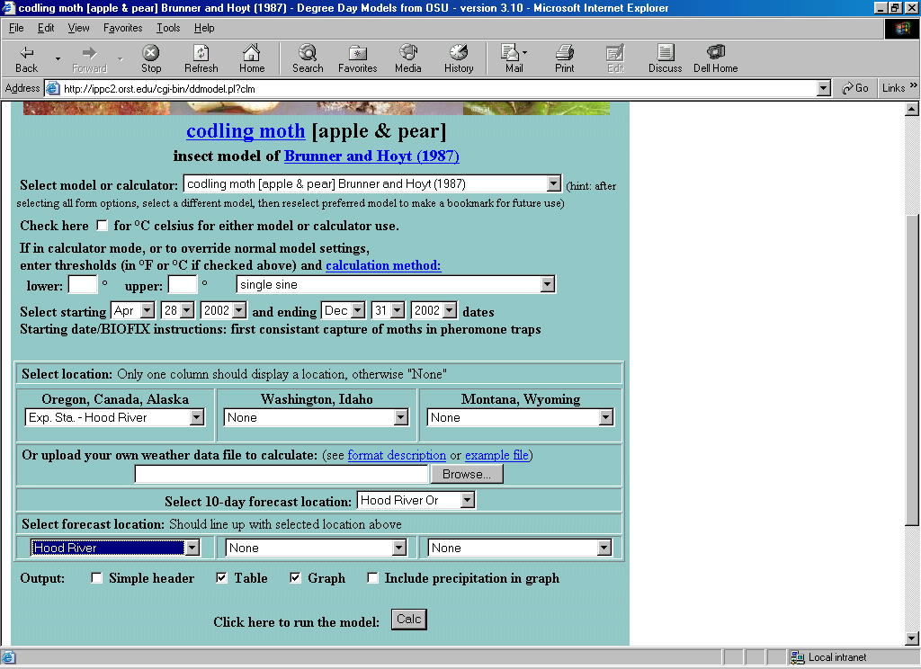
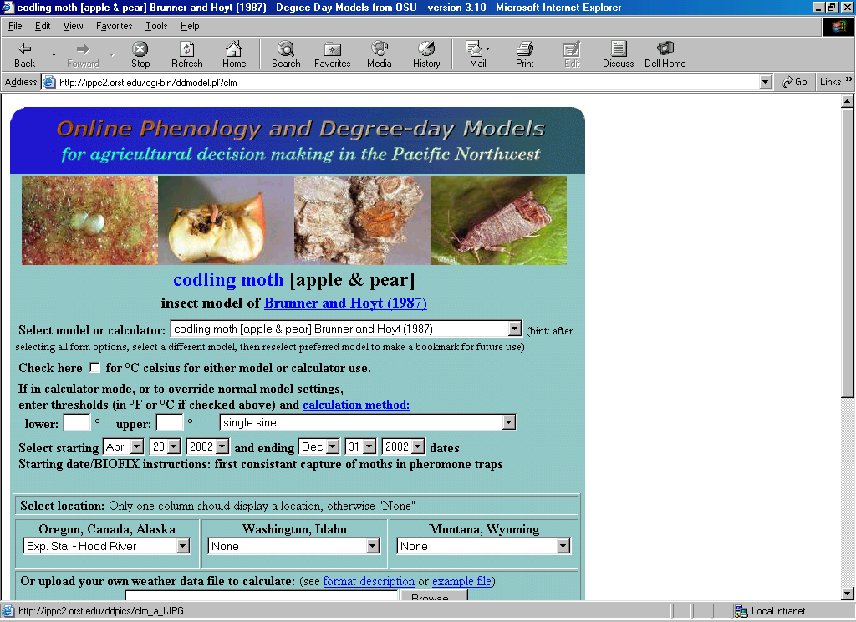

Select model

Select start (biofix) and end dates

Select station location for weather data or use your own weather data

Models will use weather forecast to extend run out ten days

When all parameters have been selected, click on "Calc" to start model
Models will use historical weather data to extend until end of season

Model output includes a summary of model input parameters, a table of key events in the development and control of the pest, a table listing daily maximum and minimum temperatures, precipitation, degree-days, and total degree-days accumulated since the biofix. Pest development events relevant to control are indicated.
Summary: Once learning the basics on accessing and using phenology and disease risk models, one may try a model of particular interest. If you know of a model that could help with pest management decision making but lack time or confidence to use regularly, then contact your local Extension service and request help in using or supporting these models.

